Software Requirements Specification
for
AUTOMATED ATTENDANCE PORTAL
Version 1.0 approved
Prepared by
Anand Parashar
Antriksh Tyagi
Devraj Gupta
Ansh Srivastava
KIET Group of Institutions
February 2023
Table of Contents
Table of Contents ii
Revision History ii
1. Introduction 1
1.1 Purpose 1
1.2 Document Conventions 1
1.3 Intended Audience and Reading Suggestions 1
1.4 Product Scope 2
1.5 References 2
2. Overall Description 3
2.1 Product Perspective 3
2.2 Product Functions 4
2.3 User Classes and Characteristics 4
2.4 Operating Environment 5
2.5 Design and Implementation Constraints 5
2.6 User Documentation 6
2.7 Assumptions and Dependencies 6
3. External Interface Requirements 6
3.1 User Interfaces 6
3.2 Hardware Interfaces 7
3.3 Software Interfaces 8
3.4 Communications Interfaces 9
4. System Features 9
4.1 Eye Tracking Feature 9
4.2 Yawning Detection 10
5. Other Nonfunctional Requirements 12
5.1 Performance Requirements 12
5.2 Safety Requirements 12
5.3 Security Requirements 12
5.4 Software Quality Attributes 13
5.5 Business Rules 13
6. Other Requirements 13
Appendix A: Glossary 14
Appendix B: Analysis Models 16

Introduction

Purpose
The purpose of this document is to present a detailed description of the open-source software. It will explain the purpose and features of the software, the interfaces of the software, what the software will do and the constraints under which it must operate. This document is intended for users of the software and also potential developers.

Document Conventions
This Document was created based on the IEEE template for System Requirement Specification Documents.

Intended Audience and Reading Suggestions
- Typical Users, such as IT organizations, who want to use Attendance Management System for their employees.
- Advanced and professional Users, such as engineers and researchers, who want to use attendance management system for proctoring and monitoring purposes.
- Programmers who are interested in working on the project by further developing it or fix existing bugs.

Product Scope
The Attendance Management System using facial recognition technology is a transformative initiative designed to streamline and modernize the process of tracking student attendance in educational institutions. The scope of this project encompasses several key areas, ensuring a comprehensive, efficient, and user-friendly solution that addresses the diverse needs of students, teachers, and administrators.

- Core Functionality

- Automated Attendance Tracking:
  - The primary scope of the project is to automate the attendance-taking process using facial recognition technology. This eliminates the need for manual attendance, reducing errors and saving valuable time during class sessions.

- RFID Integration:
  - The system integrates RFID technology to ensure secure and unique identification of students. Each student is issued an RFID card that links to their profile, providing an additional layer of security and ensuring accurate data association.

- Real-Time Processing:
  - The project aims to provide real-time attendance tracking. As students enter the classroom, the system immediately processes their facial data and marks their attendance, providing instant feedback and updates.

- System Architecture

- Database Management:
  - Utilizing MySQL, the system maintains a robust and scalable database to store all student information, attendance records, and class schedules. This ensures data integrity and facilitates easy retrieval and reporting.

- Backend Server:
  - The system is supported by an Apache server that manages data requests, handles user authentication, and ensures secure communication between the frontend and backend components. This server-side management ensures reliability and scalability.

- PHP Modules:
  - The project includes several PHP modules that handle different functionalities, such as user registration, class management, attendance logging, and report generation. These modules are designed to work together seamlessly, ensuring smooth operation and efficient data processing.

- User Interface

- Teacher and Admin Dashboards:
  - The system provides intuitive dashboards for teachers and administrators. These dashboards offer easy access to attendance records, student profiles, class schedules, and various reports, enhancing the user experience and improving productivity.

- Student Interface:
  - Students can access their attendance records and other relevant information through a dedicated interface. This transparency helps students keep track of their attendance and ensures accountability.

- Future Enhancements

- Advanced Facial Recognition Algorithms:
  - The project scope includes potential future enhancements involving more advanced deep learning algorithms, such as convolutional neural networks (CNNs) and recurrent neural networks (RNNs), to improve recognition accuracy and speed.

- Mobile Application Development:
  - Expanding the project to include mobile applications for iOS and Android platforms would provide greater flexibility. Teachers and administrators could manage attendance from their mobile devices, and students could use their smartphones for identification.

- Integration with Learning Management Systems (LMS):
  - Integrating the Attendance Management System with existing LMS platforms could offer a holistic view of student engagement and performance. This integration would allow for comprehensive data analysis, correlating attendance with academic performance.

- Advanced Analytics and Predictive Modelling:
  - Implementing advanced analytics could provide deeper insights into attendance patterns and student behaviour. Predictive models could help identify trends and potential issues, enabling proactive interventions.

- Multi-Modal Biometric Authentication:
  - Future developments could incorporate additional biometric technologies, such as fingerprint scanning and voice recognition, to provide multi-modal authentication, further enhancing the system’s security and reliability.

- Operational and Compliance Considerations

- User Training and Support:
  - The project scope includes provisions for user training to ensure that teachers, administrators, and students can effectively use the system. Ongoing support is also planned to address any issues and aid as needed.

- Data Privacy and Security:
  - Ensuring compliance with relevant data privacy laws and institutional policies is a critical aspect of the project. The system is designed with robust security measures to protect sensitive information and maintain confidentiality.

- Scalability and Flexibility:
  - The system is designed to be scalable, capable of handling increasing numbers of students and classes without performance degradation. Its modular architecture allows for easy updates and customization to meet evolving needs.

In conclusion, the scope of the Attendance Management System project is comprehensive, addressing current needs while anticipating future requirements. By leveraging cutting-edge technology and prioritizing user experience, the project aims to revolutionize attendance management in educational institutions, making it more efficient, accurate, and secure.

References

[1] Shreyak Sawhney, Karan Kacker, Samyak Jain, Shailendra Narayan Singh, Rakesh Garg, “Real-Time Smart Attendance System using Face Recognition Techniques”, 2020

[2] Naman Gupta, Purushottam Sharma, Vikas Deep, Vinod Kumar Shukla, “Automated Attendance System Using OpenCV”, 2019

[3] Krishna Mridha, Nabhan Tawjih Yousef, “Study and Analysis of Im- plementing a Smart Attendance Management System Based on Face Recognition Technique using OpenCV and Machine Learning”, 2021

[4] Organization, S. D. I. W. C., Kuster, B. (2018). Face Detection and Face Recognition in Python Programming Language. The Seventh International Conference on Informatics and Applications (ICIA2018).

[5] Emami, Shervin Suciu, Valentin. (2012). Facial Recognition using OpenCV. Journal of Mobile, Embedded and Distributed Systems.

[6] Yuvaraj, C. Srikanth, M. Kumar, V. Srinivasa Murthy, Y.V. Koolagudi, Shashidhar. (2017). An approach to maintain attendance using image processing techniques. 1-3. 10.1109/IC3.2017.8284353.

[7] Nirmalya Kar, Mrinal Kanti Debbarma, Ashim Saha, and Dwijen Rudra Pal. Study of Implementing Automated Attendance System Using Face Recognition Technique. International Journal of Computer and Commu- nication Engineering, Vol. 1, No. 2, July 2012.

[8] Suma S L, Sarika Raga, “Real Time Face Recognition of Human Faces by using LBPH and Viola Jones Algorithm,” International Journal of Scientific Research in Computer Science and Engineering, Vol.6, Issue.5, pp.6-10, 2018.

Overall Description

Product Perspective
The management of the attendance can be a great burden on the teachers if it is done by hand. To resolve this problem, a smart and auto attendance management system is being utilized. But authentication is an important issue in this system. The smart attendance system is generally executed with the help of biometrics. Face recognition is one of the biometric methods to improve this system. Being a prime feature of biometric verification, facial recognition is being used enormously in several such applications, like video monitoring and CCTV footage system, an interaction between computer & humans and access systems presents indoors and network security. By utilizing this framework, the problem of proxies and students being marked present even though they are not physically present can easily be solved. The main implementation steps used in this type of system are face detection and recognizing the detected face.
Automatic face recognition (AFR) technologies have made many improvements in the changing world. Smart Attendance using Real-Time Face Recognition is a real-world solution which comes with day-to-day activities of handling student attendance system.
Face recognition-based attendance system is a process of recognizing the students face for taking attendance by using face biometrics based on high - definition monitor video and other information technology.
It helps in conversion of the frames of the video into images so that the face of the student can be easily recognized for their attendance so that the attendance database can be easily reflected automatically.
This paper proposes a model for implementing an automated attendance management system for students of a class by making use of face recognition technique, by using Eigenface values, Principal Component Analysis (PCA) and Local Binary Patterns Histograms (LBPH) algorithm. After these, the connection of recognized faces ought to be conceivable by comparing with the database containing student's faces. This model will be a successful technique to manage the attendance and records of students.

Product Functions
GET- GET function used to get roll no ,current time, class name, date , image path, faces after image processing .
Submit – to submit the final attendance.

User Classes and Characteristics
- Typical Users, such as IT organizations, who want to use attendance management system for their employees.
- Advanced and professional Users, such as engineers and researchers, who want to use attendance management system for proctoring and monitoring purposes.
- Programmers who are interested in working on the project by further developing it or fix existing bugs.

Operating Environment
- Windows 2000
- Windows XP
- Windows Vista
- Windows 7
- Windows 8
- Windows 10
- Mac OS X
- Linux

Design and Implementation Constraints
Attendance management system is developed in python, which uses some Machine learning algorithms.
It uses open-source libraries like TensorFlow and OpenCV for the input and performing the calculations based on the provided input. It does the recognition of face for computation.
All the output is based on the given inputs and computations sone by the applied algorithms.

User Documentation
There is a quick Guide available on the website-

Assumptions and Dependencies
Attendance management system is developed in python and therefore it requires to install python libraries into the user’s system. This version of attendance management system applies to Windows and Linux users.

External Interface Requirements

User Interfaces
The user interface for the Drowsiness Detection system will consist of the following components:
- Camera: Camera will be mounted to capture the face of the employee.
- Indicator: The system will use indicators to provide feedback to the employee. Green light will indicate that the employee is alert and red light will indicate that the employee is drowsy.
- Database entry: The system will store the data of the employee in case of drowsiness.
- User Interface: The system will have a simple and intuitive user interface for configuring and monitoring the system. It will allow the user to start and stop the system and adjust the settings.
- Data display: The system will display data such as drowsiness level, time of detection, another alert issued on user interface.
- Help Button: A help button will aid and contact support inn case of any issues or questions.

Hardware Interfaces
- Operating System:
- x86 64-bit CPU
- 4 GB RAM
- 2 GB free disk space.

Software Interfaces
- User Interface: The User Interface will provide a graphical user interface (GUI) for the user to interact with the system. It will allow the user to start and stop the system, view face, and take attendance and also adjust settings.
- Camera Interface: The Camera Interface will enable the system to capture video feed from the camera. It will provide access to the camera hardware and allow the system to adjust camera settings such as resolution, brightness, and contrast.

- Facial Recognition Interface: The Facial Recognition Interface will enable the system to detect and analyze the student facial features. It will provide access to facial recognition algorithms and machine learning models used for attendance management systems.

- Data Storage Interface: The Data Storage Interface will enable the system to store the data collected during the training, including the time of facial detection, image path, and any alerts issued. It will provide access to a database or file system to store and retrieve data.

- Network Interface: The Network Interface will enable the system to communicate with external devices or services. It will provide access to network protocols and APIs for transmitting data, receiving updates, and accessing remote services such as cloud storage or analytics platforms.

- Configuration Interface: The Configuration Interface will enable the user to submit, review ,edit , and data storage preferences. It will provide a GUI for configuring the system and storing user preferences.

Communications Interfaces
- The system will communicate with the camera interface to capture video feed from the camera.
- The system will communicate with the facial recognition interface to analyze the student's facial features.
- The system will store data and submit the attendance automatically.

System Features
- Automated Attendance Recording
  - The system leverages facial recognition technology to automate the attendance recording process. This minimizes manual intervention and ensures accuracy in attendance tracking.

- RFID Integration
  - The system uses RFID technology to identify classes and timings. When a student scans their RFID card, the system fetches the relevant class and schedule information to ensure that the attendance is logged at the correct time.

- Real-time Data Processing
  - Attendance data is processed in real-time, providing instant updates to the database. This ensures that attendance records are up-to-date and can be accessed by administrators and teachers at any time.

- Face Detection and Recognition
  - The system uses the Local Binary Patterns Histogram (LBPH) for facial recognition. This technique is robust and works well in varying lighting conditions, ensuring accurate student identification.

- Grayscale Image Processing
  - During the training phase, facial images are converted to grayscale to reduce computational complexity and enhance recognition accuracy. Grayscale images retain essential facial features while simplifying the image data.

- Web Interface for Administration
  - Administrators can access a web interface to manage classes, students, and attendance records. This interface is built using PHP and allows for easy manipulation and retrieval of data stored in the MySQL database.

- Error Handling and Validation
  - The system includes error handling mechanisms to manage incorrect RFID entries, invalid time slots, and unrecognized faces. This ensures smooth operation and provides feedback to users for corrective actions.

- Detailed Reporting
  - The system can generate detailed attendance reports for each class and student. These reports can be used by teachers and administrators to monitor attendance patterns and identify irregularities.

- Database Security and Integrity
  - The MySQL database is designed to ensure data integrity and security. Attendance records are stored securely, and access to sensitive data is restricted to authorized users only.

- Configurable Settings
  - The system includes configurable settings for classroom assignments, timing thresholds, and facial recognition parameters. This flexibility allows the system to be tailored to the specific needs of different educational institutions.

- Scalability
  - The system is designed to be scalable, allowing for easy addition of new classes, students, and RFID cards. This makes it suitable for use in institutions of varying sizes.

- Notification System
  - The system can be configured to send notifications to students and teachers via email regarding attendance records, upcoming classes, and other relevant updates.

- Backup and Recovery
  - Regular backups of the attendance data are maintained to prevent data loss. In case of any system failure, the data can be recovered from the backups to ensure continuity.

- User-Friendly Interface
  - Both the web interface and the system's physical interface (e.g., RFID scanner and camera setup) are designed to be user-friendly, ensuring ease of use for students, teachers, and administrators.

These features collectively contribute to a robust, efficient, and user-friendly attendance management system that leverages modern technologies to streamline the process of attendance tracking and management in educational institutions.

Other Nonfunctional Requirements

Performance Requirements
- The system must be able to detect face in real-time with a maximum latency of 1 second.
- The system must operate continuously for at least 4 hours without any performance degradation.

Safety Requirements
- The system must not distract the employee while working, and the feedback must not be too intrusive.
- The system must not interfere with the normal functioning of the system on which it is installed.

Security Requirements
- The system must use secure data storage and transmission protocols to protect the data collected during the working time.
- The system must be resistant to attacks such as tampering or spoofing of facial features.

Software Quality Attributes
- The system must be reliable and accurate in detecting facial features with a low rate of false positives and false negatives.
- The system must be maintainable and extensible to allow for future updates and improvements.

Business Rules
- The system must comply with any legal and regulatory requirements for working privacy.

Other Requirements
- The system must be compatible with a wide range of cameras and facial recognition algorithms to accommodate different hardware and software configurations.
- The system must have a user manual or documentation explaining how to use and configure the system.
Appendix A: Glossary
- Attendance Management System (AMS):
  - A system designed to automate the process of recording and managing student attendance in educational institutions using technologies such as RFID and facial recognition.
- RFID (Radio-Frequency Identification):
  - A technology that uses electromagnetic fields to automatically identify and track tags attached to objects. In this project, RFID is used to identify students and link them to their respective classes.
- Facial Recognition:
  - A biometric technology that uses unique facial features to identify and verify individuals. In this project, facial recognition is used to verify student identities and record attendance.
- Local Binary Patterns Histogram (LBPH):
  - A face recognition technique that labels the pixels of an image by thresholding the neighborhood of each pixel and considers the result as a binary number. LBPH is robust and works well under different lighting conditions.
- Grayscale Image:
  - An image in which the value of each pixel carries only intensity information. In this project, facial images are converted to grayscale to simplify the image processing and recognition tasks.
6. Haar Cascade Classifier:
  - A machine learning object detection method used to identify objects in an image or video. In this project, it is used to detect faces in real-time video streams.
7 Real-time Processing:
- The capability of the system to process data and provide results almost instantaneously. In this project, attendance data is processed in real-time as students are recognized.
8 Database Schema:
- The structure that represents the logical configuration of the entire or a part of the database. It defines how the data is organized and how the relationships among the data are associated.

Appendix B: Analysis Models
Data Flow Diagram
Level 0
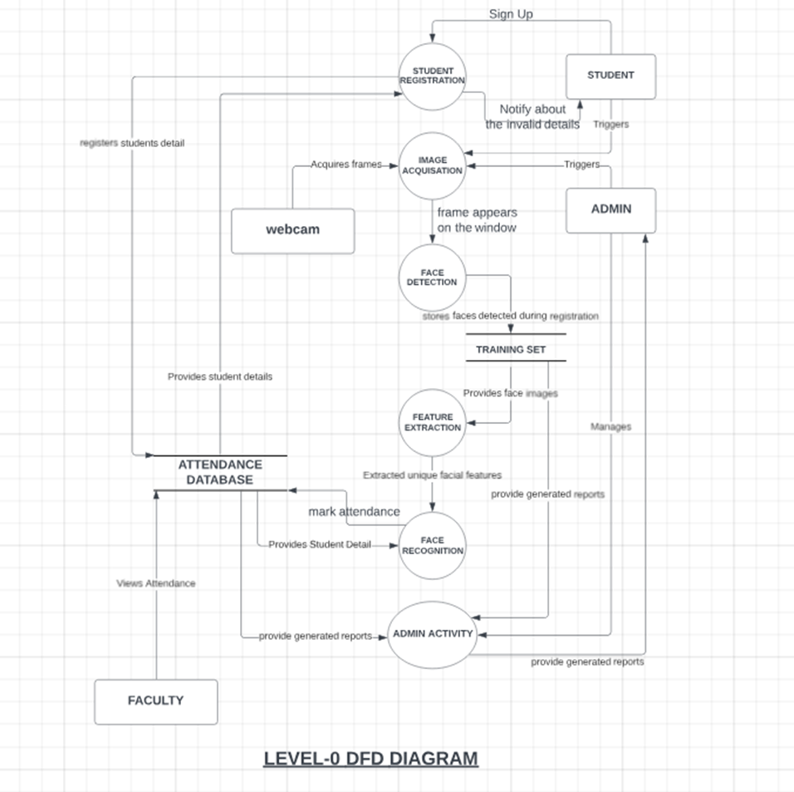
Level 1
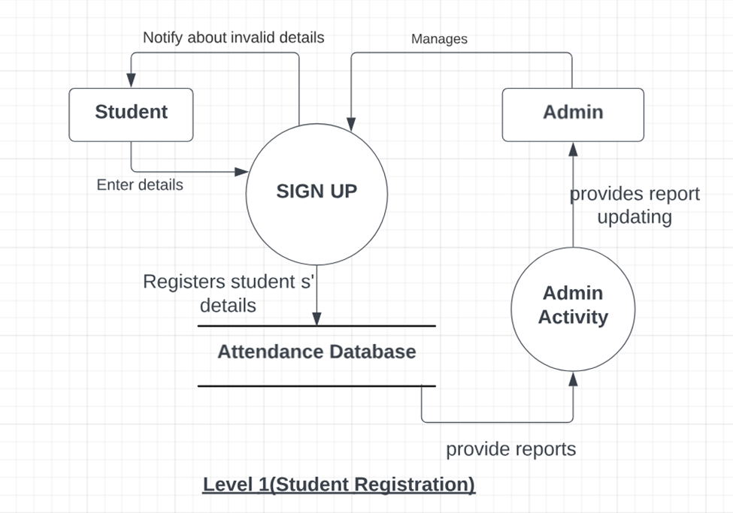
Level-2
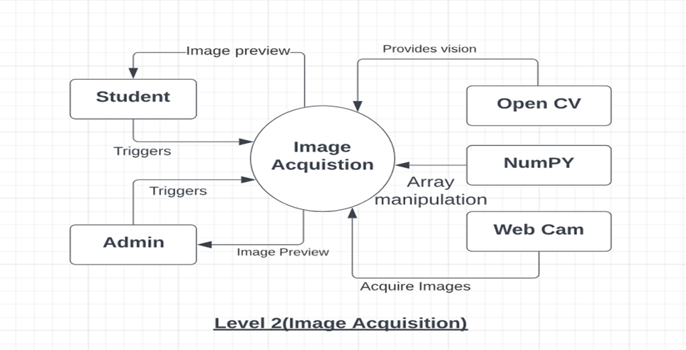
Level-3
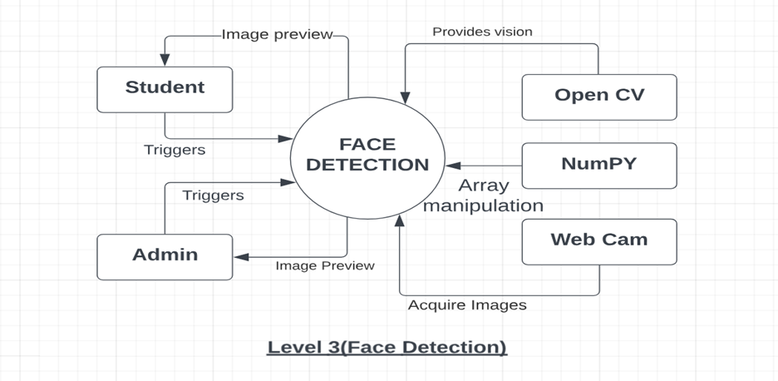
Level-4
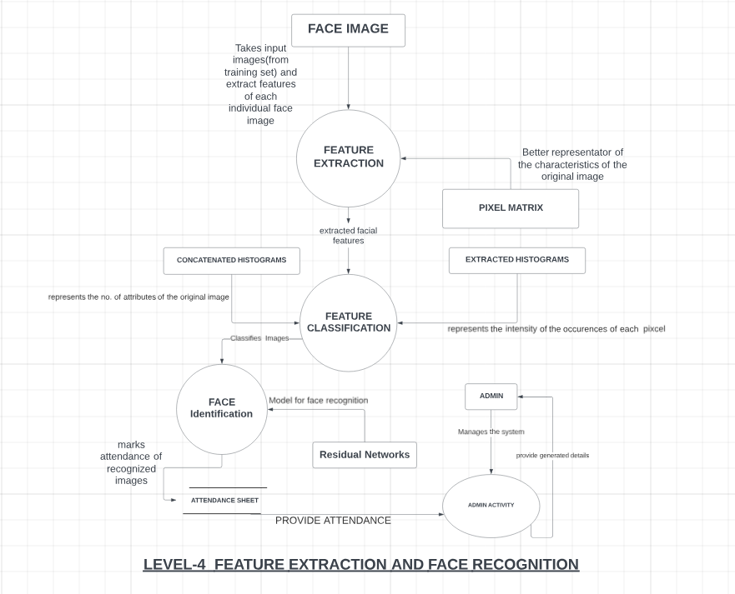
Use Case Diagram
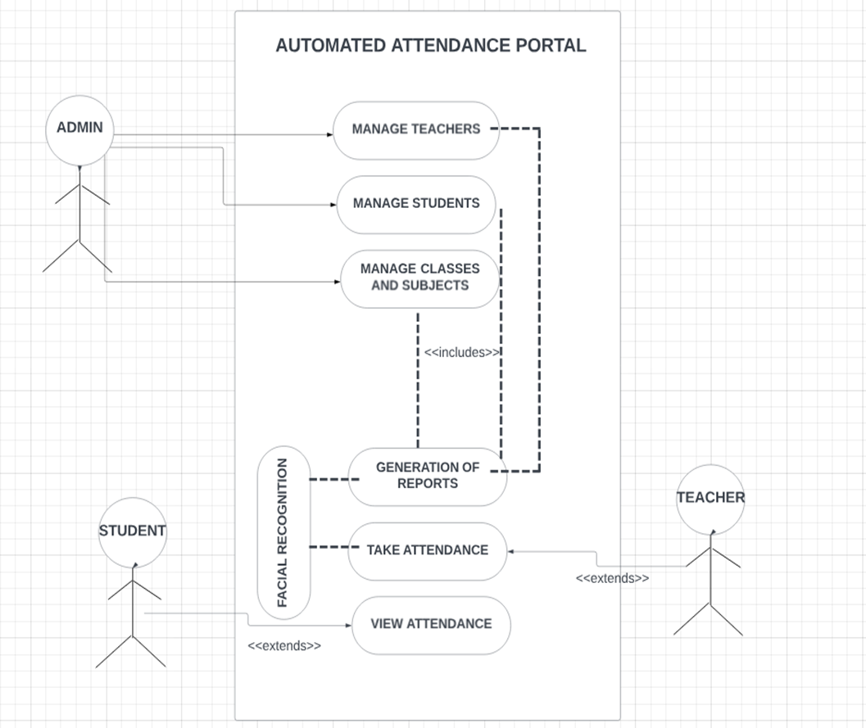

ER DIAGRAM
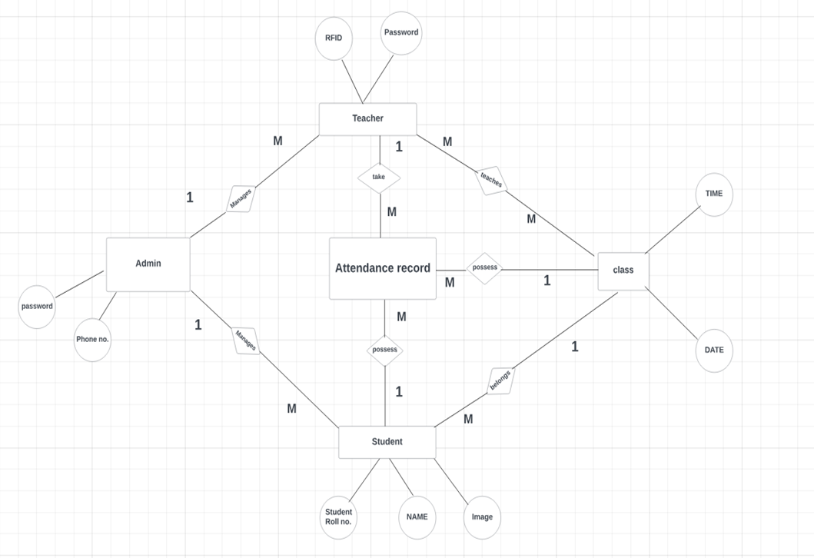

Process Flowcharts
Admin Process Flowchart
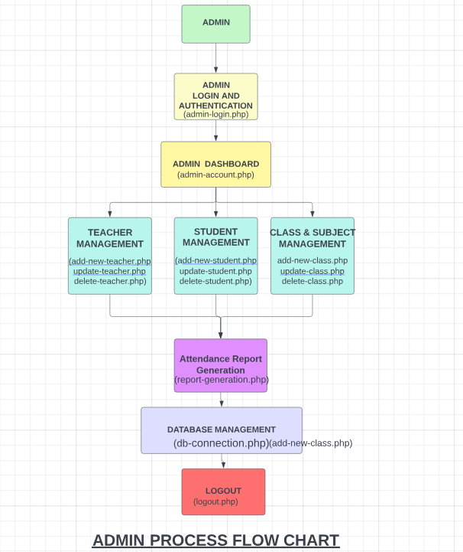

Faculty Process Flowchart
